SINHGAD FORT / GHAT CLEANING CAMPAIGN REPORT
Activities Description.
As Mahatma Gandhi said, “Cleanliness is next to Godliness”. The saint from Maharashtra, 'Saint Gadagebaba' spent his entire life to make people aware about importance of cleanliness in our life. Also our honorable Prime Minister Shree Narendra Modi has taken a great initiative to clean India by announcing 'Swachha Bharat Abhiyan ‘which aims at cleaning our Country from various kind of garbage.
Waste is a big obstacle in the path of progress and we all are equally responsible for it. Whether we create it or not, it is our responsibility to reduce and inculcate sustainable methods of waste reduction. Keeping this in mind, PYF has been giving small contributions for the welfare of society. To add to our contribution for our PM's initiative of 'Swachha Baharat’, we decided to conduct activity of cleaning the jewel of Shivaji maharaja’s swarajya, 'The Sinhgad fort'.

SKNCOE took one step towards this mission by undertaking cleanliness drive on date19 August 2018. Students cleaned by collecting the non- disposable waste like plastic bags, plastic bottles, wrappers and non-degradable material. SKNCOE student volunteers along with local people took pledge for keeping the Sinhgad fort clean and pollution free. To spread awareness in people, we placed posters on different places which talks about importance of cleanliness and how we can achieve that goal.

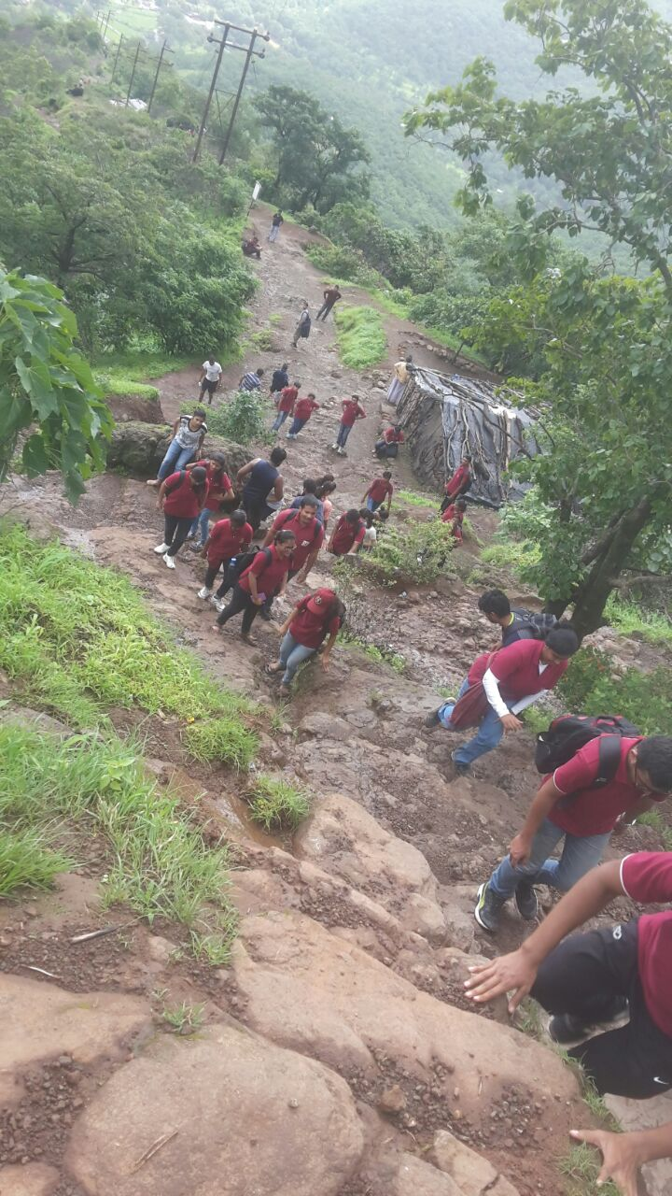
The Sinhgad cleaning was the motto of the team which was fulfilled with tremendous spirit 30 BAGS i.e. 200 kg of non-biodegradable waste was collected.
